Pokhara University

Level: Bachelor | Semester – Fall | Year : 2008
Programme: BE |  | Full Marks : 100
Course: Electronic Devices |  | Time : 3hrs.

Candidates are required to give their answers in their own words as far as practicable.
The figures in the margin indicate full marks.

Attempt all the questions.

1. | - What is non-linear device? Find the piecewise linear model of a silicon diode with I_{s} = 10⁻¹¹ A and 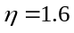in the vicinity of the operating point I_{D} = 1mA.  - What is reverse recovery time of PN junction diode? Explain with the help of necessary circuit diagram and waveforms. | 7  8
2. | - In the circuit given load current varies from 15 mA to 100 mA. Find the value of series resistance R to maintain the voltage of 10 V across the load. The minimum zener current is 10 mA. 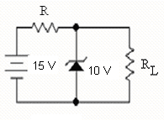  - Explain the V - I characteristics of PN junction diode with necessary plot and equations. | 7  8
3. | - Compare CB, CC and CE configurations of BJT in terms of current gain, input impedance, output impedance, voltage gain, phase shift and applications.  - Explain the working principle of NPN transistor. Find the relation between α and β. | 7  8
4. | - What is operating point? For the transistor shown below, V_{CC} = 15V, R₁ = 10K Ώ, R₂  = 5 KΏ , R_{C} = 1K Ώ  R_{E} = 2K Ώ  and R_{L} = 1K Ώ.  Assume V_{BE} = 0.7V.  (i) Draw d.c. and a. c. equivalent circuits  (ii) Determine the operating point.  - The transistor shown in figure below has the following h-parameter values: hie = 1600 Ώ, hfe=80, hre = 2x10⁻⁴, hoe = 20μS. Find: i) Zi ii) rin(stage) iii) Av = Vce/Vbe iv)V_{L}/Vs v)Ai and vi) Zo(stage)  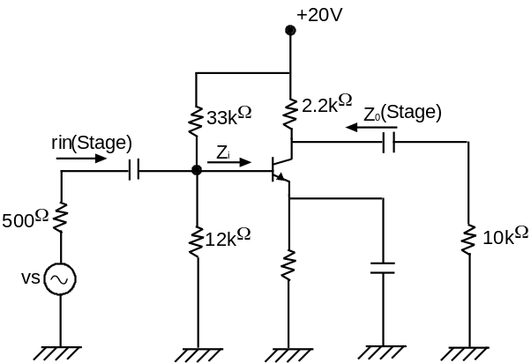 | 8  7
5. | - For the circuit given, Find out Drain Current and Drain to source voltage at operating point. Given IDSS = 12 mA, VP = -6 V 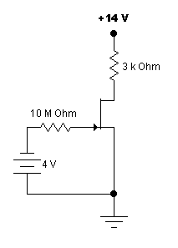  - Explain the operation of N-channel JFET.What is pinch off voltage? Draw the transfer characteristic curves for N-channel JFET. | 7  8
6. | - Draw Full wave Bridge rectifier circuit and explain its operation. Compare half wave rectification and full wave rectification in terms of Ripple factor, Efficiency and Root mean Square Value.  - Sketch the output waveform for the circuit given below. It is given that discharging time constant m (CR_{L}) is much greater than the time period of input wave.  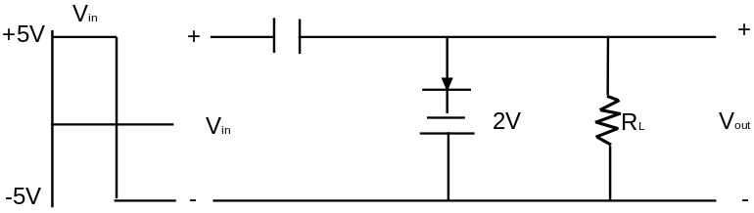 | 8  7
7. | Write short notes on (Any Two)  - High Frequency t - model of BJT  - working of n-channel MOSFET in triode region  - r-model of BJT | 5×2

